This is a detailed solution design. I'll build it out architecture by architecture, with diagrams and structured analysis for each.

Architecture A — Azure Files + Azure File Sync
This architecture keeps the on-prem Windows Server VM as the active file server, with Azure File Sync replicating data continuously to an Azure Files share. In a DR event, clients redirect to the Azure Files endpoint directly.###
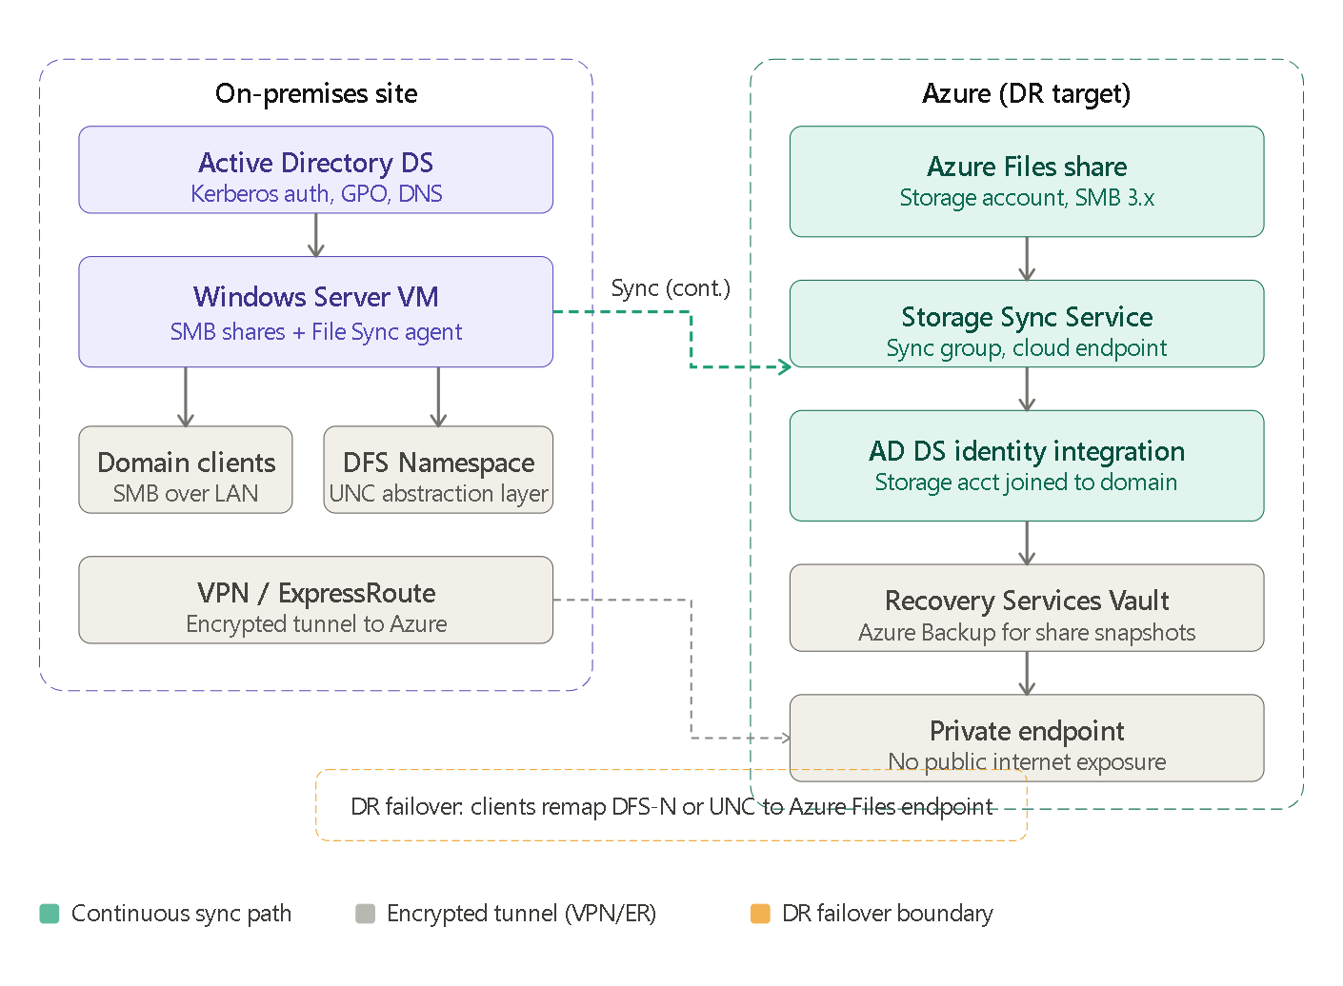
Architecture A: setup and configuration steps
Prerequisites
- Azure subscription with a Storage Account (StorageV2, LRS or GRS depending on RPO target)
- ExpressRoute or Site-to-Site VPN already operational (minimum 100 Mbps recommended for initial seeding)
- On-prem file server running Windows Server 2016 or later (required for File Sync agent)
- Entra ID tenant with Azure AD Connect or Entra Connect synchronizing on-prem AD identities
Step 1 — storage account and identity integration
Create the Storage Account and enable AD DS authentication. This involves running the AzFilesHybrid PowerShell module, which registers the storage account as a computer object in your on-prem AD (or Azure AD DS). This issues a Kerberos service ticket when domain-joined clients mount the share, preserving the native authentication experience.
# Register storage account to on-prem AD
Join-AzStorageAccount -ResourceGroupName "rg-dr" `
-StorageAccountName "safiledr" `
-Domain "corp.contoso.com" `
-DomainGuid "..." -DomainName "corp.contoso.com" `
-DomainSid "..." -ForestName "contoso.com" `
-NetBiosDomainName "CONTOSO" -Credential $cred
Assign share-level RBAC roles (Storage File Data SMB Share Contributor or Elevated Contributor) to your AD security groups. NTFS-level ACLs are then set using icacls or Windows Explorer after mounting the share from a domain-joined machine.
Step 2 — deploy Azure File Sync
Deploy the Storage Sync Service resource in Azure. Install the Azure File Sync agent on the on-prem Windows Server VM. Register the server, create a sync group, add the Azure Files share as the cloud endpoint, and add the on-prem share path as the server endpoint. Enable cloud tiering if storage capacity management is needed (not recommended for DR scenarios where you want full local copies).
Step 3 — private endpoint and network isolation
Create a private endpoint for the storage account within your Azure VNet. Disable public network access on the storage account. Update on-prem DNS to resolve safiledr.file.core.windows.net to the private IP via a conditional forwarder pointing to Azure Private DNS.
Step 4 — Azure Backup for Azure Files
Register the storage account with a Recovery Services Vault. Configure an Azure Backup policy for the file share (daily snapshots, retention up to 180 days). This provides a separate point-in-time recovery path independent of File Sync.
Step 5 — DFS Namespace configuration
Create a DFS Namespace with two targets: the on-prem file server path (preferred, priority 1) and the Azure Files SMB endpoint (standby, priority 2, initially disabled or set to lower priority). This provides the abstraction layer needed for client-transparent failover.
Architecture A: data synchronization and failover process
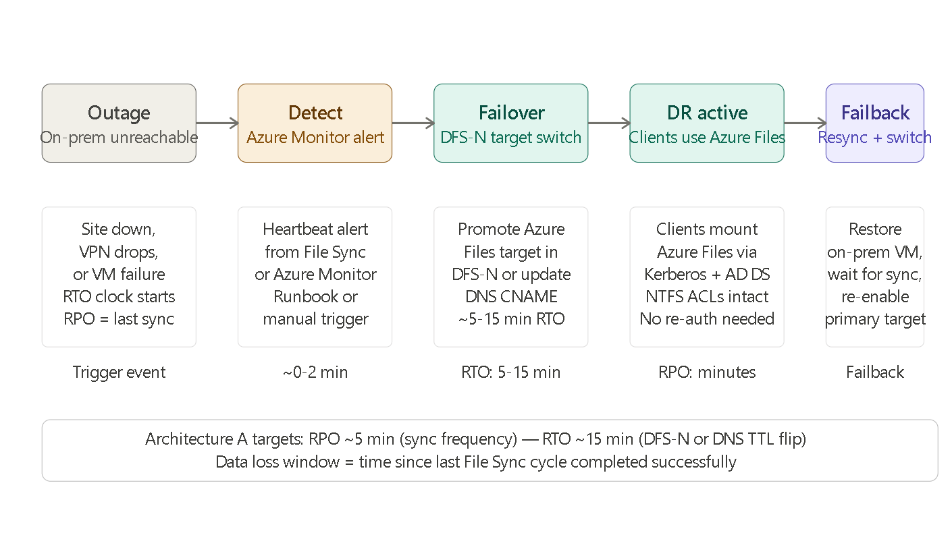
Sync frequency and RPO mechanics: Azure File Sync uses a near-real-time change detection mechanism — file changes are uploaded within minutes, typically achieving an RPO of 5–15 minutes for active file shares. The sync agent monitors the server endpoint for changes and uploads deltas to the cloud endpoint continuously. During a DR event, the maximum data loss equals the lag of the last successful sync cycle. If the on-prem VM crashes mid-write, any uncommitted changes not yet synced are lost.
Failover trigger options:
- Manual: an operator promotes the Azure Files DFS-N target after confirming the outage
- Automated: an Azure Automation Runbook triggered by an Azure Monitor alert (e.g., File Sync heartbeat missed + VPN tunnel down) can update the DFS-N target programmatically via PowerShell
Failback process:
- Restore the on-prem VM from backup (or resolve the infrastructure issue)
- Restart the File Sync agent; it will detect the Azure Files share as authoritative and pull down any changes made during DR
- Wait for sync convergence (verify in the Azure Portal sync status blade)
- Re-promote the on-prem target in DFS-N and demote the Azure Files target back to standby
- Drain any open file handles before the switch to avoid client disruption

Architecture B — Azure standby Windows Server VM
This architecture deploys a Windows Server VM in Azure IaaS, configured to replicate data from the on-prem file server using Azure Site Recovery (for VM-level failover) or Robocopy/DFS Replication (for file-level sync). It mirrors the on-prem environment most closely.

Architecture B: setup and configuration steps
Prerequisites
- Azure subscription with a Recovery Services Vault
- VNet in Azure with sufficient address space (should not overlap on-prem subnets)
- Site-to-Site VPN or ExpressRoute
- ASR provider registered in the Recovery Services Vault
- Optional: a read-only domain controller VM in Azure, or Azure AD DS provisioned in the same VNet (required for Kerberos auth in DR without VPN connectivity to on-prem DCs)
Step 1 — configure Azure Site Recovery
Deploy the ASR Configuration Server on-prem (or use a Process Server topology for larger environments). Install the ASR Mobility Service agent on the Windows File Server VM. Set up replication policy: RPO target (typically 15 minutes minimum for crash-consistent, or application-consistent with VSS every 1–4 hours), retention points (up to 72 hours crash-consistent, 24 snapshots app-consistent).
Step 2 — prepare the Azure network
Create a VNet with subnets for the DR VM and domain services. Deploy an Azure Bastion host for secure RDP access post-failover. Provision either a DC replica VM in Azure (a domain controller on Windows Server joined to the same AD forest, replicating from on-prem) or Azure AD DS (managed, no infrastructure to maintain but cannot be a writeable DC in the forest).
Step 3 — configure the DR VM sizing
In the ASR replication settings, pre-configure the target VM size, VNet placement, and OS disk type. The VM remains deallocated (not billed for compute) until failover is triggered. Only storage costs accrue in steady state.
Step 4 — SMB share and permission configuration on DR VM
ASR replicates the entire VM disk, including NTFS permissions, share definitions, and the registry entries that define SMB shares. This means no additional ACL reconfiguration is needed post-failover — the VM is an exact replica.
Step 5 — DNS and DFS-N pre-staging
Pre-configure a DFS-N target pointing to the DR VM's hostname (not yet active). Prepare an Azure Private DNS zone that resolves the DR VM name. This allows fast failover by simply enabling the DFS-N target or updating a DNS A record TTL.

Architecture B: data synchronization and failover process
Replication model: ASR uses a block-level continuous replication approach. The Mobility Service agent captures writes at the kernel level and ships deltas to the Azure replication cache (a standard storage account). These are then committed to managed disks attached to the standby VM. Crash-consistent recovery points are created every 5 minutes; app-consistent (VSS) points are created per the configured frequency.
Failover sequence:
- Outage detected (automated: Azure Monitor heartbeat loss, or manual declaration)
- ASR failover initiated from the Recovery Services Vault — selects a recovery point (latest, or a specific crash/app-consistent snapshot)
- Azure starts the standby VM from the replicated disk
- VM boots into Windows Server, SMB Server service starts automatically, shares are visible
- If an Azure DC replica or Azure AD DS is in the VNet, Kerberos auth works immediately for domain-joined clients connecting over VPN; if on-prem DCs are unreachable, only Azure AD DS or the DC replica in Azure can issue tickets
- DFS-N target updated or DNS record flipped — clients reconnect with no UNC path change
Failback sequence:
- On-prem VM restored and re-joined to domain
- ASR Reprotect operation initiated — this reverses replication direction, using the Azure VM as the source and replicating changes back to on-prem storage
- Once delta sync completes, trigger planned failover back to on-prem
- Re-enable on-prem DFS-N target, disable Azure target
- Optionally deallocate the Azure VM to stop compute billing

Security, permissions, and IAM
Both architectures maintain NTFS ACL fidelity, but through different mechanisms.
In Architecture A, NTFS ACLs are carried by the File Sync agent during initial seeding and delta syncs. The Azure Files share enforces these ACLs natively once the storage account is domain-joined. Share-level access is governed by Azure RBAC (Storage File Data SMB Share Contributor) assigned to AD security groups synchronized to Entra ID. Windows Defender for Storage provides real-time anomaly detection on the storage account, including ransomware canary detection and malware hash scanning on upload.
In Architecture B, NTFS ACLs are part of the replicated VM disk — they are preserved bitwise because ASR replicates the entire volume. No additional ACL mapping is required. The security perimeter in DR is the Azure VNet NSG plus the VPN/ExpressRoute boundary. Azure Defender for Servers covers the VM, and Windows Defender runs inside the guest OS identically to on-prem.
For both architectures, Conditional Access policies in Entra ID can enforce MFA and device compliance for any client connecting through Azure (whether to an Azure Files endpoint or to an Azure VM's SMB share via VPN). Auditing pipelines differ: Architecture A uses Azure Monitor diagnostic logs on the storage account (sent to Log Analytics / Microsoft Sentinel); Architecture B uses Windows Security Event Log forwarding from the Azure VM to the same Log Analytics workspace.
Key IAM consideration for multi-domain/multi-forest environments: Architecture A's AD DS integration supports only a single domain registration per storage account. If file servers are spread across separate forests, each forest needs its own storage account, complicating the DR topology. Architecture B naturally handles multiple forests because the VM maintains its own domain membership independently per forest, identical to the on-prem configuration.

Performance and availability considerations
Architecture A introduces a latency floor equal to the round-trip time from the client to the Azure Files endpoint. Over ExpressRoute with a local peering point, this is typically 5–20ms — acceptable for most document workloads but potentially disruptive for applications with chatty SMB patterns (many small sequential I/Os). Azure Files Standard uses HDD-backed storage with up to 60 MiB/s throughput per share (scalable with share size); Premium uses SSDs with up to 10 GiB/s. Cloud tiering in File Sync can cause recall latency spikes if a client opens a tiered file — in DR mode, all files should already be in Azure, so tiering is not a concern.
Architecture B preserves the full Windows Server file service stack in Azure. Clients connect via VPN, experiencing the same latency they would with Architecture A for the WAN hop, but the VM can use Premium SSD managed disks for sub-millisecond local I/O if the application opens files via a network path internal to the VM (e.g., mapped drives through VPN). The VM can be sized independently — a D4s v5 (4 vCPU, 16 GiB RAM) is a reasonable starting point for a file server handling 100–200 concurrent users. VM availability can be improved by placing it in an Availability Zone, giving a 99.99% SLA.
One critical difference: during steady state, Architecture A's DR target is always warm (the Azure Files share exists and is continuously updated). Architecture B's standby VM is deallocated — it must boot, which adds 3–8 minutes to RTO. Architecture A can therefore achieve a lower practical RTO for straightforward failovers.

Cost and operational overhead
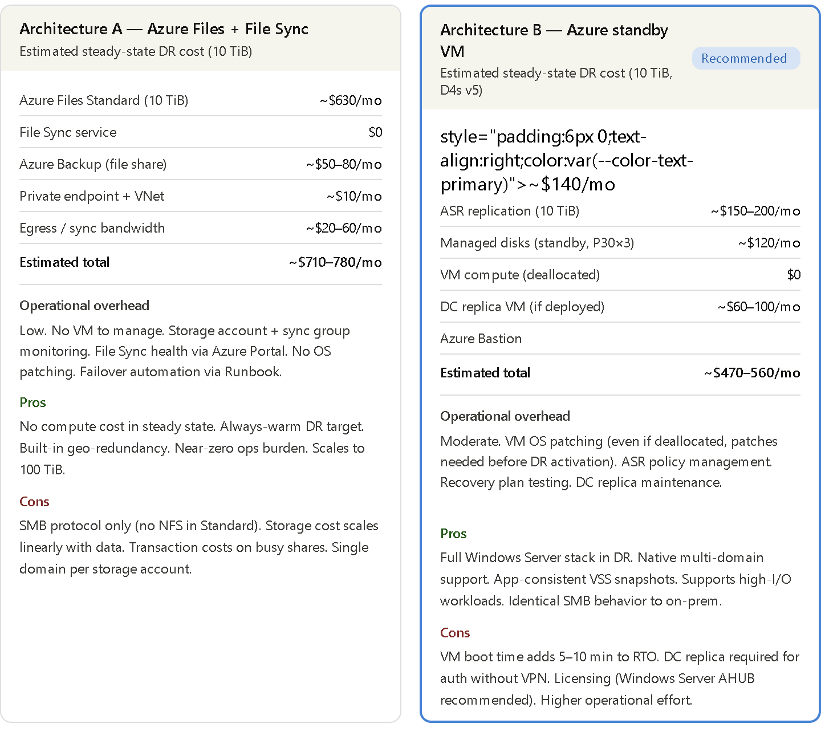
Note: Architecture B's cost advantage at 10 TiB narrows or reverses at smaller data volumes, where Azure Files storage costs are lower. At 50 TiB+, Architecture A's storage cost dominates and Architecture B becomes more cost-competitive. Azure Hybrid Benefit (AHUB) for Windows Server licenses reduces the VM compute cost in Architecture B significantly if you have existing Software Assurance coverage.
Decision matrix---
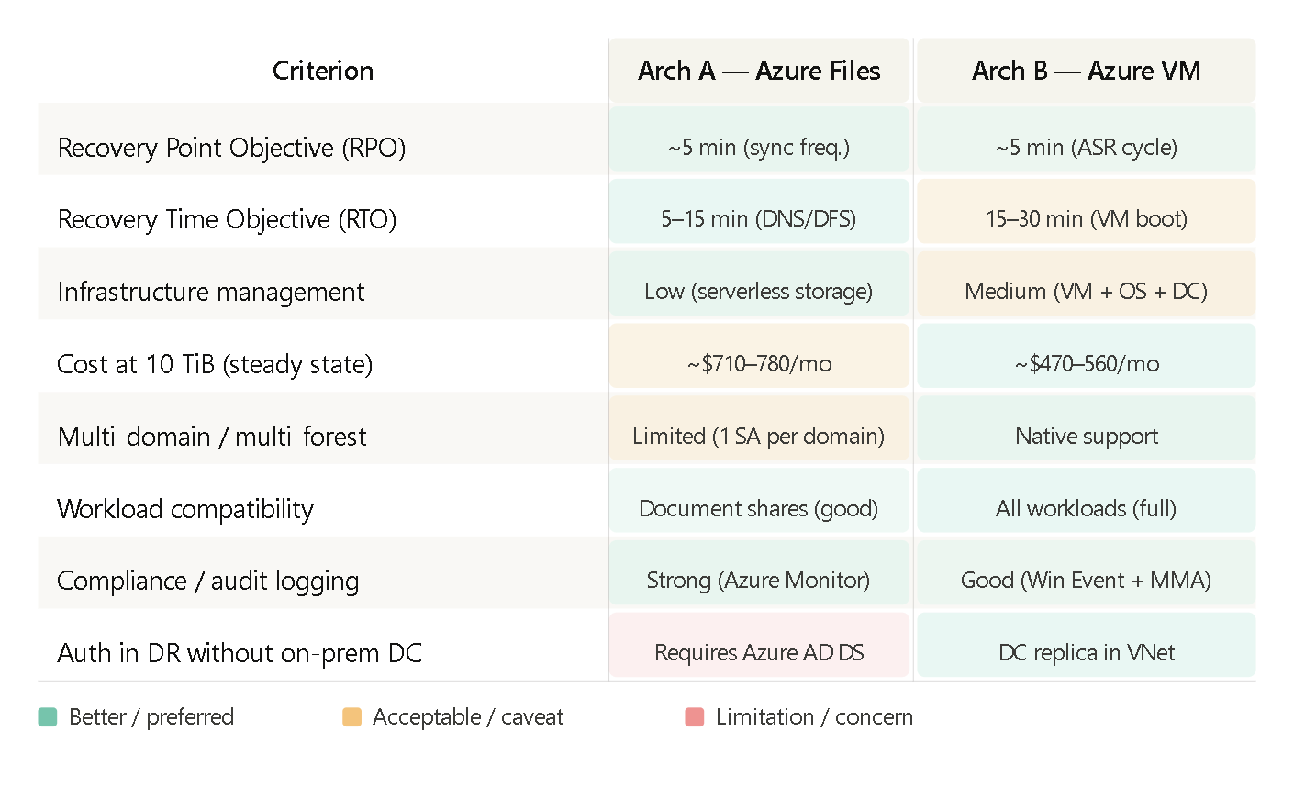
Recommended approach
For high-availability departmental file shares — Architecture A (Azure Files + File Sync) is the better fit. The DR target is always warm, RTO is lower, and ongoing operational burden is minimal since there is no VM to maintain, patch, or license in Azure. DFS Namespace provides transparent failover with no client-side change. For most departmental document sharing and home drive scenarios, the SMB latency over ExpressRoute is acceptable. If your organization already has ExpressRoute with a local peering point, this architecture delivers near-production-grade DR with the least complexity.
For regulated environments — Architecture B (Azure standby VM) is the more defensible choice, for several reasons. First, it preserves the complete Windows Server audit trail identically to on-prem, including Security Event Log entries that compliance frameworks (PCI DSS, HIPAA, ISO 27001) map to specific controls. Second, it natively supports multi-domain and multi-forest environments without requiring identity consolidation, which is frequently a blocker in regulated industries where domain separation is a security control. Third, it enables application-consistent VSS snapshots, which matter for workloads where crash-consistent recovery is insufficient (any database-backed file store, for example). Fourth, the VM-level replication model allows you to run DR failover tests via ASR's non-disruptive test failover feature — spinning up an isolated copy of the VM in a test VNet — providing auditable, documented evidence that the DR system works, which regulators often require.
In practice, many enterprise environments deploy a hybrid of both: Architecture A for the bulk of departmental file shares (lower cost, lower ops burden), and Architecture B selectively for file servers hosting sensitive or compliance-bound data where the VM-fidelity guarantee and richer audit capability are required. This is the approach worth modelling in a phased DR roadmap.

